1. What seen in Branch

Retail Loans (Pushpaka, Clean, Pension), Mudra-CERSAI,CGTMSE, ETF, Follow up of ERI

1. Reasons for Choosing IT
2. Basics of Loans(1) and Latest Updations(LPD, Master Circulars)
3. Digital/Para Banking related tasks done in Branches
4. Campaign Performance

RETAIL LOAN SCHEMES

1. **Clean Loan**

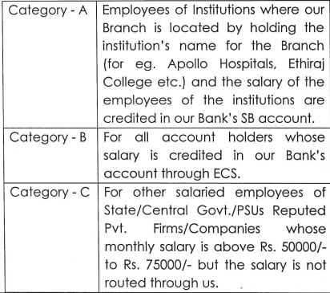

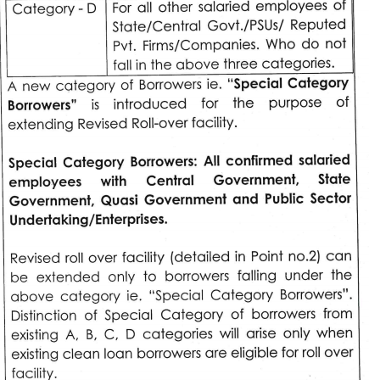

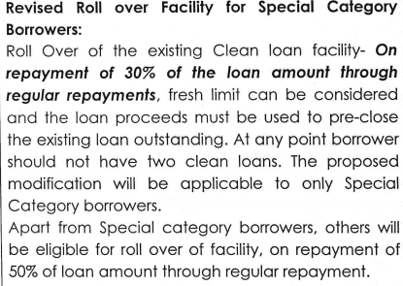

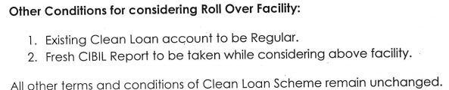

Risk Based Internal Virtual Audit

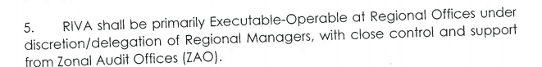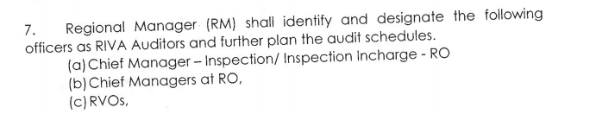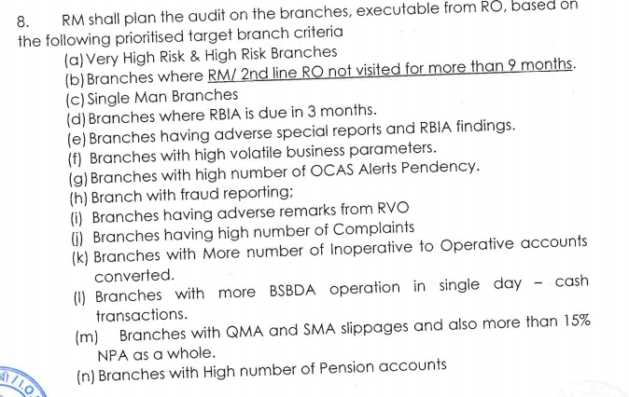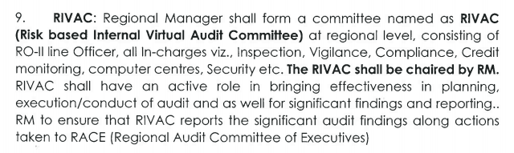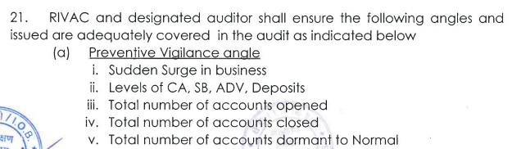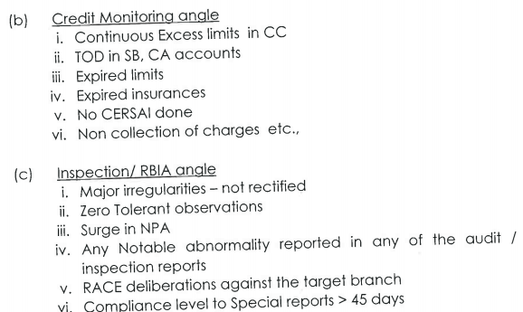

************************************************************************************

***IOB PRASTUTHI***

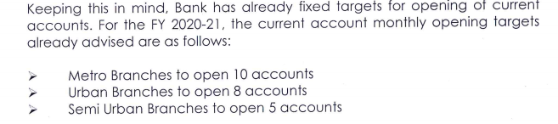

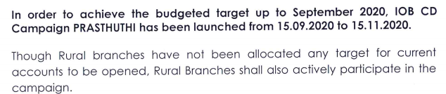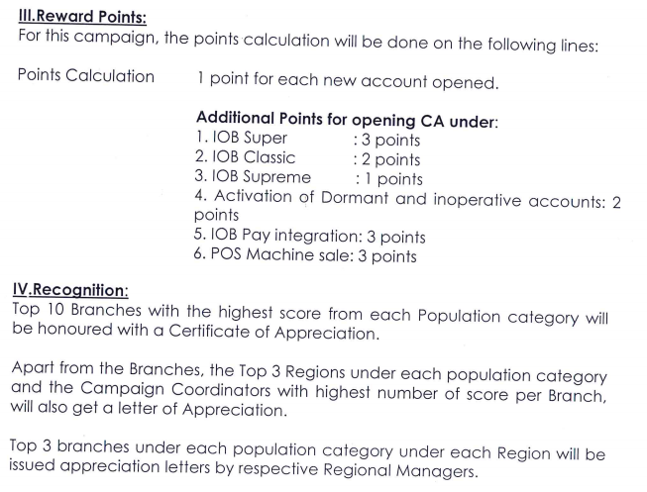

Customer Meeting-15/Sep/2020



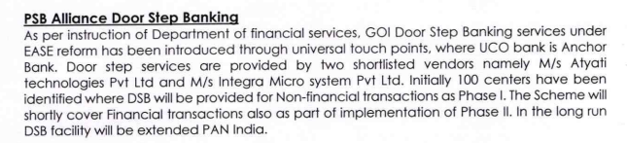

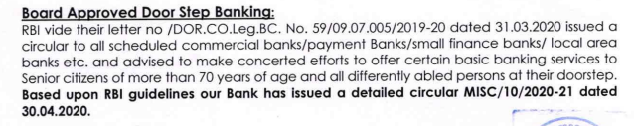

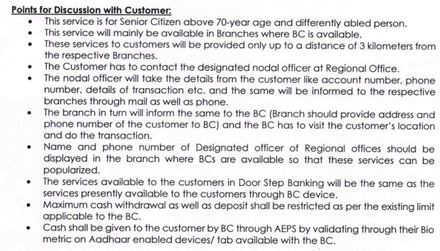

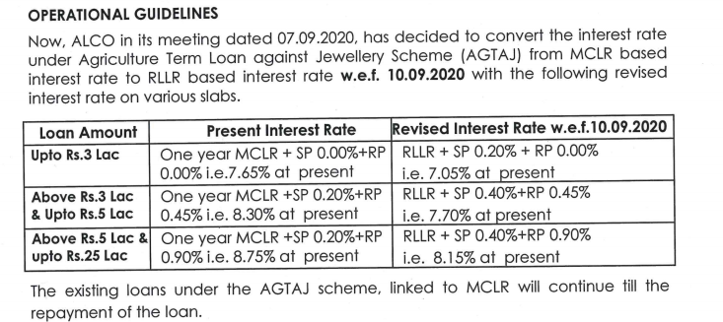

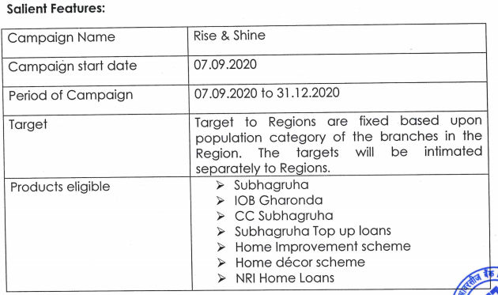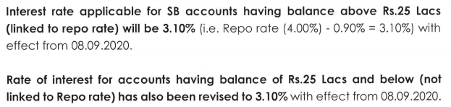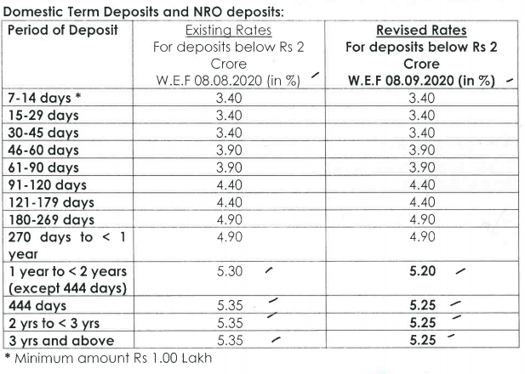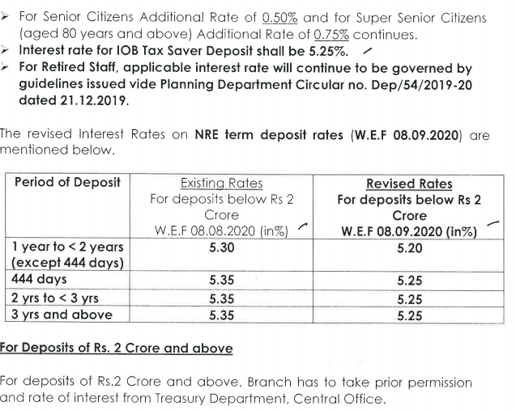

Resolutio Plan

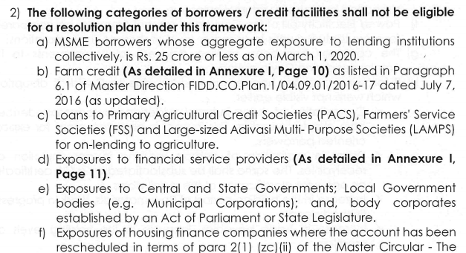

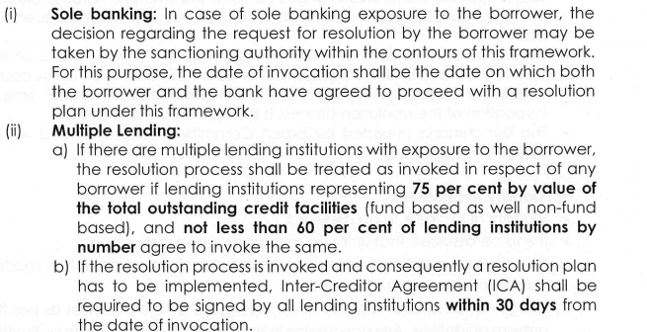

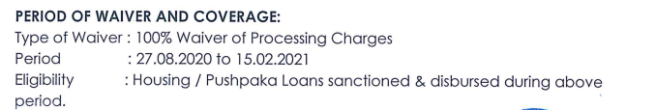

EASE Reforms

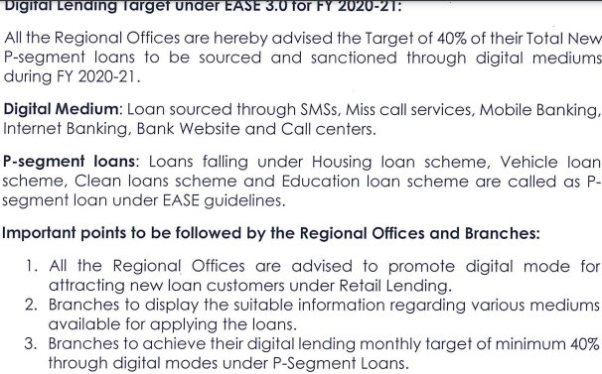

Increased LTV for Jewel Loans: 90%

Discretionary Powers

* **Guaranteed Emergency Line Credit(GECL)**

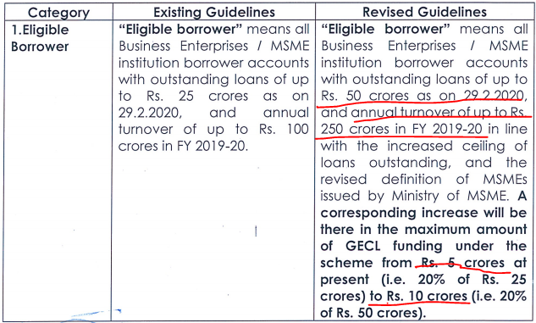

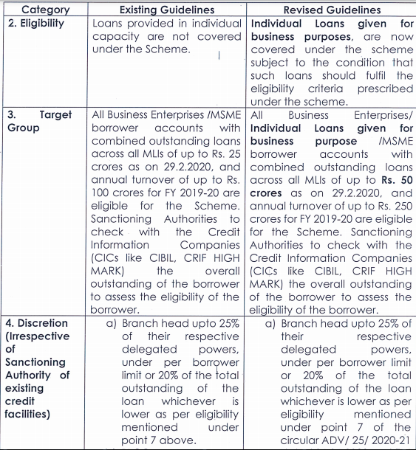

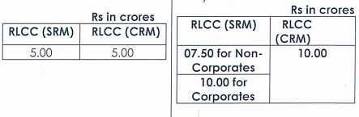

CRILC Reporting🡪 5Cr and Above advances

UIDAI Targets(AEC)

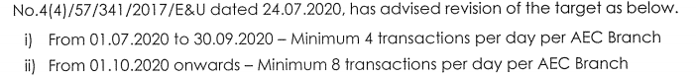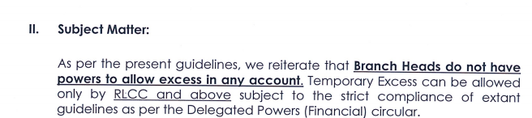

LPD 2020 Excerpts

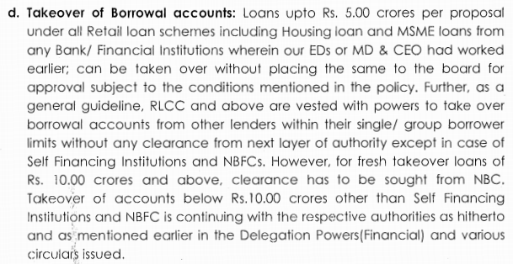

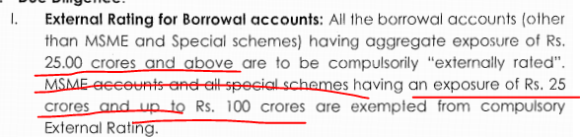

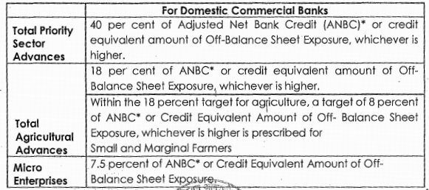

Housing Loan

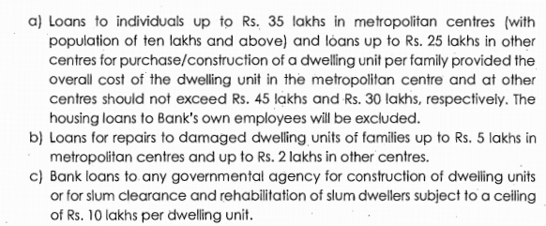

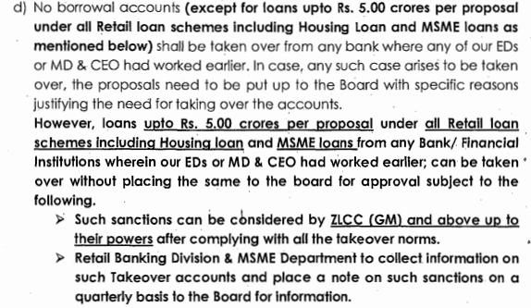

Social Infra: 5 Crores

Renewable Energy: 15 Crores.

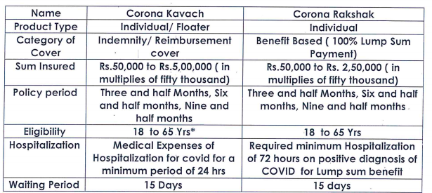

Documents taken for Basic Loans

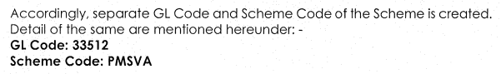

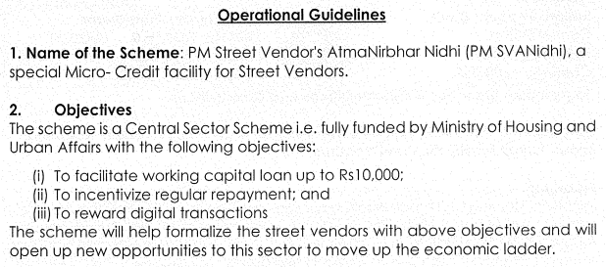

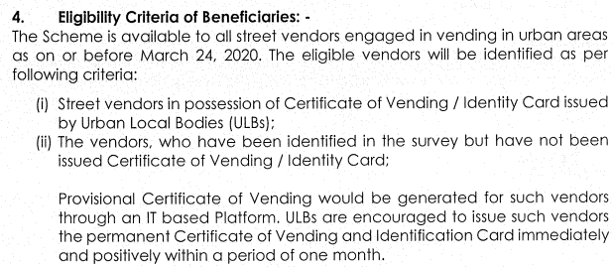 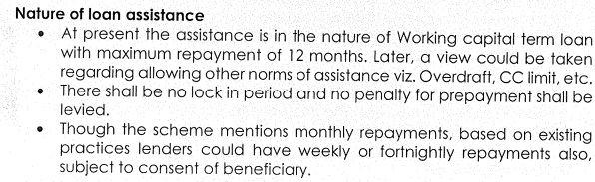 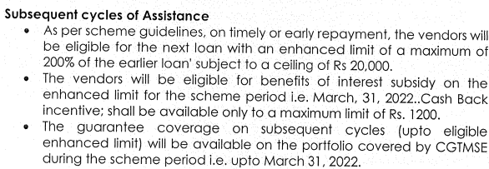 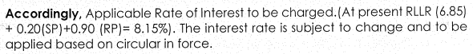

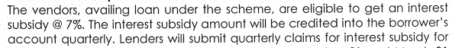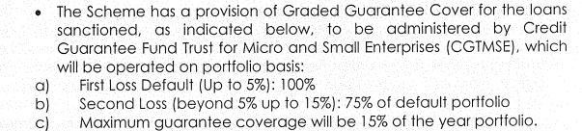

Implementation: **SIDBI**

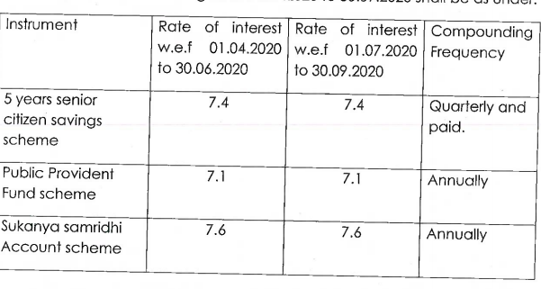 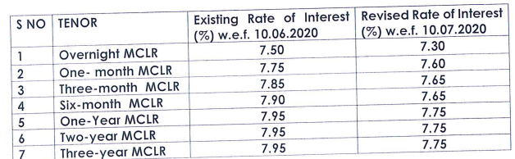 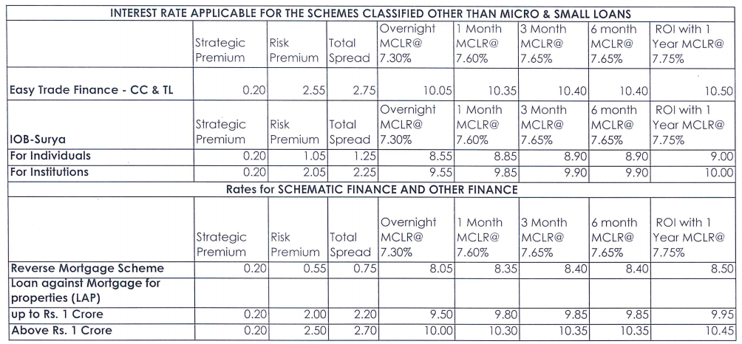

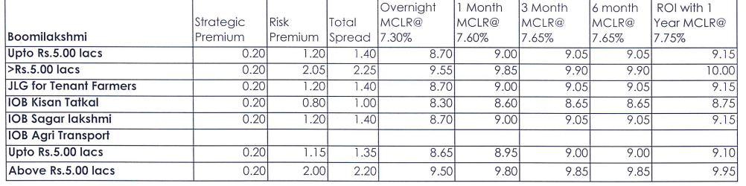

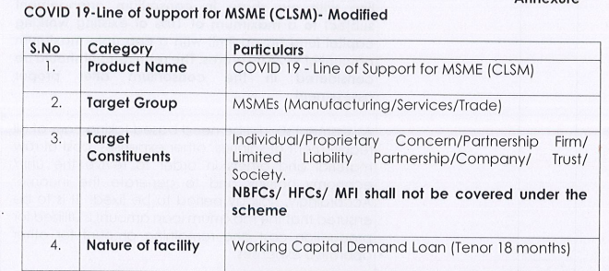

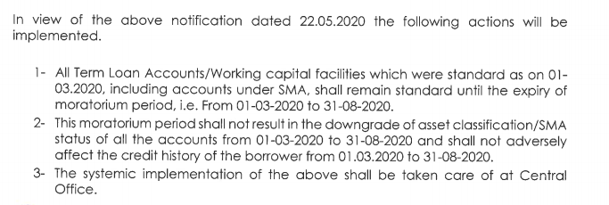



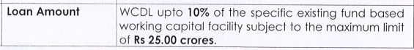

IOB6 under RAM IOB7 under CRRM

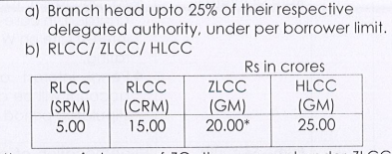

Margin: NIL

Existing MSME with good credit Record of 2 Years  
For Corporates IOB5 or BBB

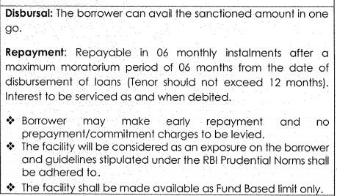

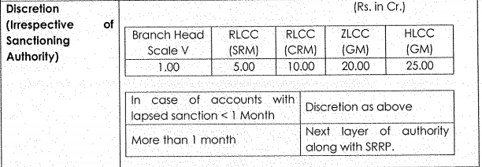

AGRI:

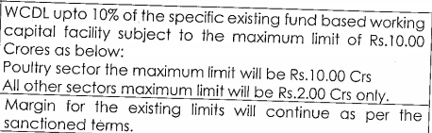

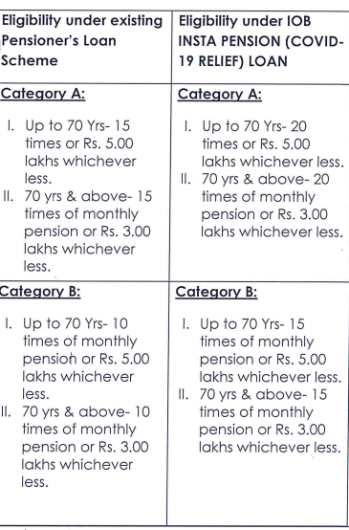

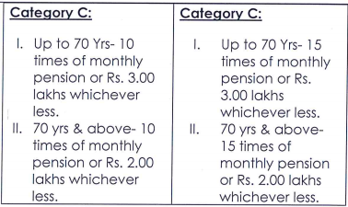

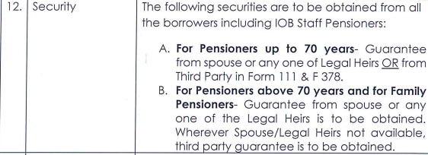

GM Names of All the Departments

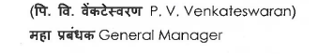

Backward Classes:

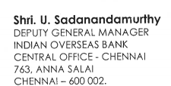

When MD Joined

ROI of Loans

Discretionary Powers

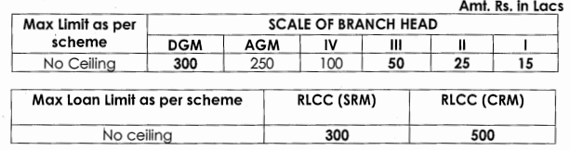

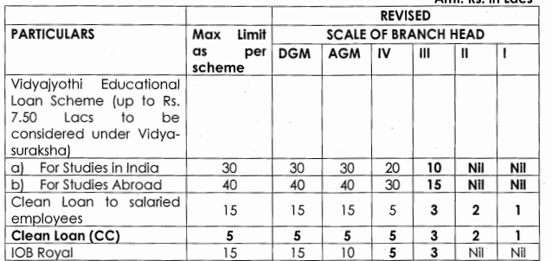

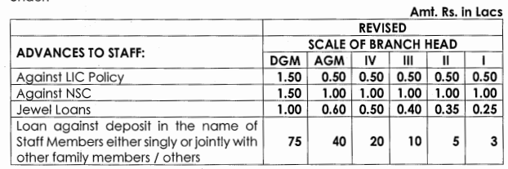

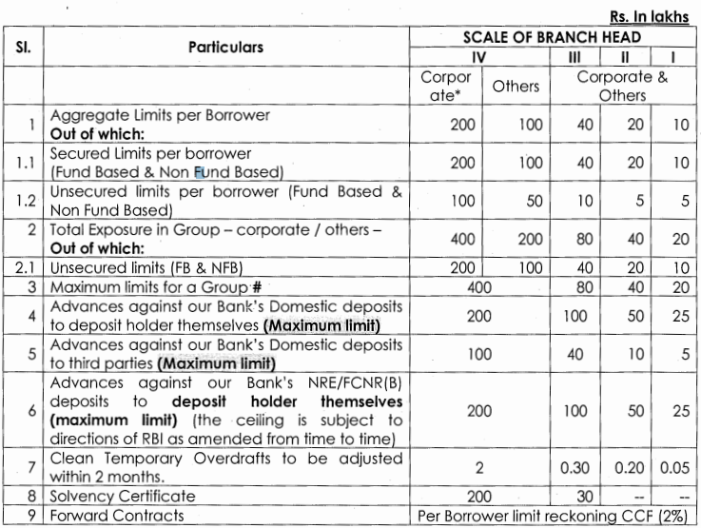

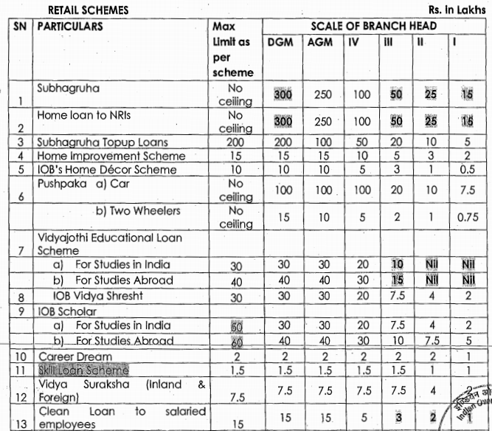

## 

## ***************************************************

## Career Guide Excerpts

## Lockers

## Lockers should be rented only to respectable persons, properly introduced to the Branch. Lockers can be rented to:

## • Individuals — Singly or jointly including non-resident Indians

## • Trusts, Hindu Undivided Family concerns

## • Societies, Clubs and Associations

## • Proprietary concerns

## • Partnership

## • Firms & Limited companies

## • Government Departments, Courts etc. where the nature of their work/business involves safe keeping of articles/documents etc.

## • Illiterate customers, visually impaired customers

## • Staff members of our Bank

## Lockers should not be hired with *“Former or Survivor”* clause.

## *Form 125 AX- Locker Agreement*

## 

## Loan Secure Policy

## *Sum insured option available ranging from minimum Rs 50000/- to max Rs 3 Crores*

## IOB Healthcare Plus

## 

## 

## 

## 

## What Is a Hurdle Rate?

A hurdle rate is the minimum [rate of return](https://www.investopedia.com/terms/r/rateofreturn.asp) on a project or investment required by a manager or investor. It allows companies to make important decisions on whether or not to pursue a specific project.  
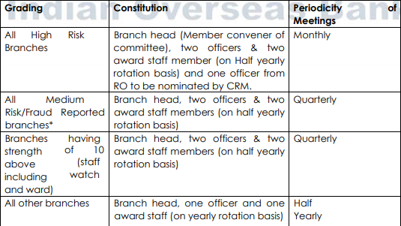 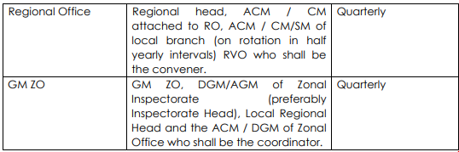 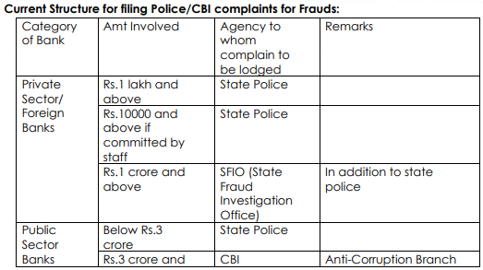

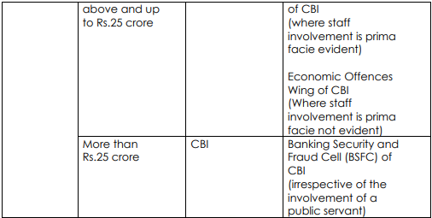

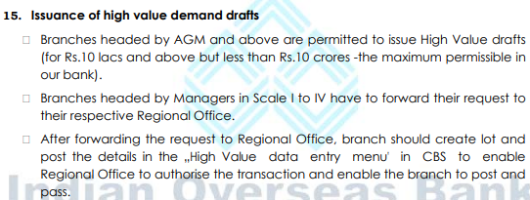

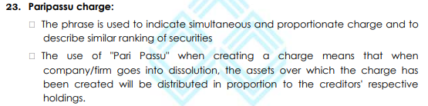

Read Office Notes of some of the loans done

EASE REFORMS

6 themes as given below:

1) Customer Responsive (CR)- EASE for customer comfort

2) Responsible Banking (RB) – Financial Stability, governance for ensuring outcomes and EASE for clean and commercially prudent business.

3) Credit off-take (CO)- EASE for the borrower and proactive delivery of credit.

4) Udayami Mitra for MSME(UM)- EASE of financing and bill discounting for MSMEs.

5) Deepening Financial Inclusion & Digitalization (FIDI)-EASE through near-home banking, micro-insurance and digitalization.

6) Ensuring Outcomes- Governance/HR (BRPSB)-Developing personnel for brand PSB.

Boston Consultancy Group (BCG) is assigned the job by IBA as per the instruction of DFS to quantify and get the data from different sources to finalize the ranking models. BCG will be collecting the data from different sources including customer survey, structured branch visit, incognito visits to quantify the progress on different parameters. BCG has partnered with KANTAR IMRB to conduct the customer and branch survey as a part of EASE index program. The survey will be carried out in 2.5% of the branch network and they will conduct survey with 4-5 customers.

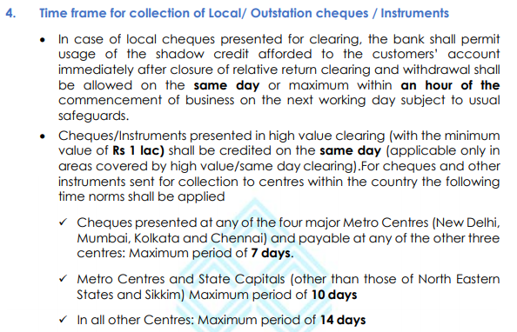

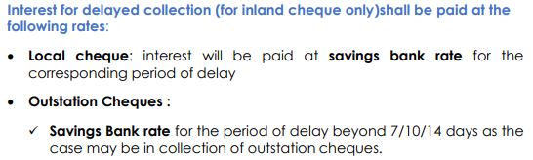 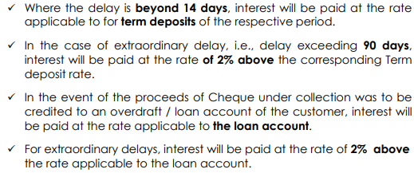

|  |  |  |  |
| --- | --- | --- | --- |
| **ROLL NO** | **NAME** | | **DEPARTMENT** |
| 32378 | SURESH R | | CENTRAL OFFICE |
| 31661 | MANORAMA K N | | CENTRAL OFFICE |
| 35343 | ANKADA RATNA PATRO B. | | CENTRAL OFFICE |
| 34740 | UMA MAHESWARI B | | CENTRAL OFFICE |
| 35346 | SHANKARA RAO R. | | CENTRAL OFFICE |
| 35334 | RABINDRA KUMAR PRADHAN | | HRMD |
| 34041 | BHUWAN CHANDRA | | CENTRAL OFFICE |
| 35359 | SUSIL CHANDRA MOHANTA | | CENTRAL OFFICE |
| 33973 | RAVICHANDRAN N | | CENTRAL OFFICE |
| 35336 | SHUBHENDU KUMAR VERMA | | CENTRAL OFFICE |
| 36461 | SUDHIR PRASAD THAKUR | | CENTRAL OFFICE |
| 36432 | NATARAJ KARYAMPUDI | | CENTRAL OFFICE |
| 37320 | RAJALAKSHMI BHAVANI SHANKAR | | CENTRAL OFFICE |
| 34833 | | GANESAN M GENERAL MANAGER & CHIEF  TECHNOLOGY OFFICER | | |  |

Manual on Documentation